User Manual for NoSkript Client Installation

1 Pre-requisites 2
2 Installing NoSkript Client Setup 2
3 Configuration of NoSkriptClientSetup 2
4 Starting the client 3
5 Connecting to Standalone devices 3

Pre-requisites
JDK 11 to be installed in system.
https://download.java.net/openjdk/jdk11/ri/openjdk-11+28_windows-x64_bin.zip

Installing NoSkript Client Setup

  - Download the zip file from the below path and extract the zip file
Path: NoSkriptClientSetup.zip
  - Install the NoSkriptClientSetup folder in C drive.
  - Set environment variable as
JAVA_HOME - C:\jdk-11.0.2 (Path of jdk in system)
  - Add Path as %JAVA_HOME%\bin.

Configuration of NoSkriptClientSetup

- Navigate to ‘conf.properties’ file in path C:\NoSkriptClientSetup\
- Open conf.properties file by right click on it and select edit with Notepad application.
- Login to NoSkript with the credentials provided.
- Select ‘Help’ menu and click copy authentication token. ‘Token Copied’ message will be displayed.
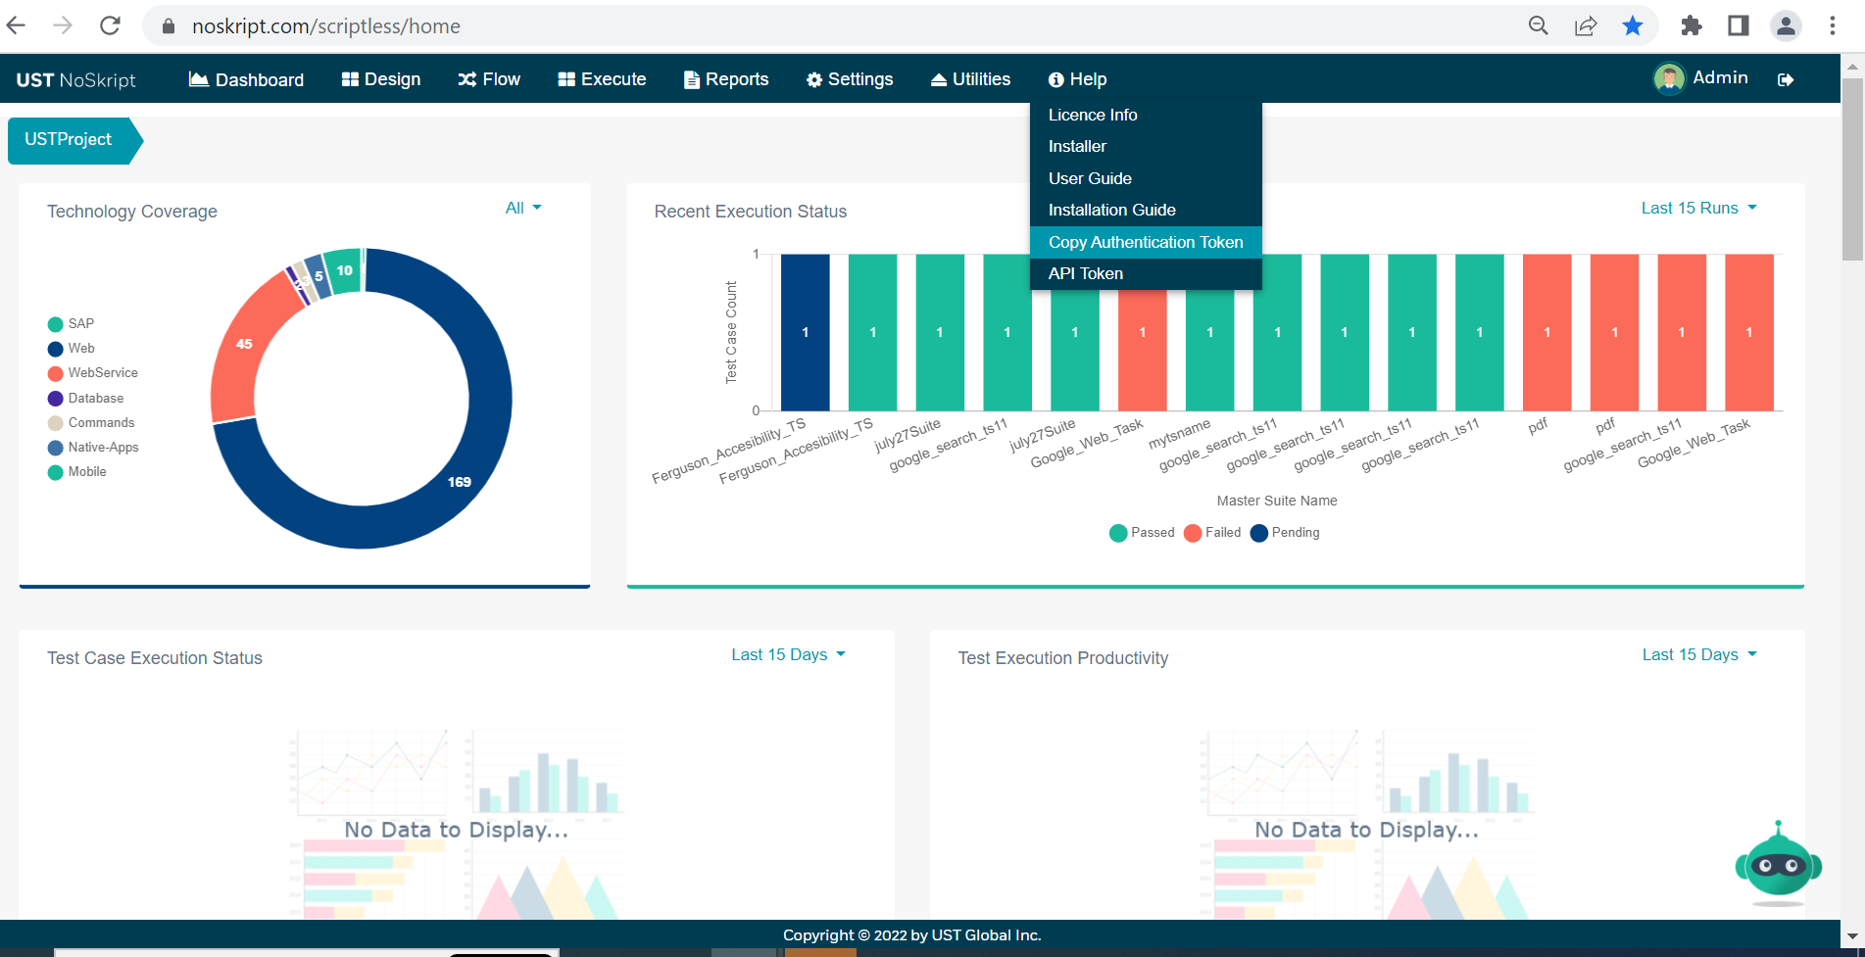
- Paste the copied token in ’USERTOKEN=’ property in conf file.
- Set chrome.binary.path= (Give the path of chrome.exe in the corresponding system.)
For Example: C:\\Program Files (x86) \\Google\\Chrome\\Application\\chrome.exe
- Set hub.ip.port = 172.29.6.25:4444 (Give the system IP address)
- Set node.details= 172.29.6.25:5555 (Give the system IP address)
- Save conf.properties file
- Set chrome.driver.path = C:/NoSkriptClientSetup/drivers/chromedriver.exe
Replace the chrome driver with the driver which has current version of your chrome browser.
We can download the required version of webdriver from chrome.
- Navigate to ‘start.bat’ file in path- C:\NoSkriptClientSetup\
- Open start.bat for edit by right clicking and selecting edit with Notepad application.
- "C:\jdk-11.0.2\bin\java.exe" -jar ust-scriptless-client-1.0.jar <LOCAL_IP > 8888
(Replace this with correct java.exe path and the corresponding IP address in your system)
- Save start.bat file

Starting the client
- Navigate to ‘start.bat’ file in path- C:\NoSkriptClientSetup\
- Double click on start file to start the client for Execution.

Connecting to Standalone devices
- Extract the below zip to C:\Android\ in your local machine
Android.zip

- Set Environment variable as: ANDROID_HOME - C:\Android\

- Add the below mentioned Paths
- %ANDROID_HOME%
- C:\Android\tools
- C:\Android\platform-tools
- C:\Android\build-tools
(Path of ‘tools’ folder you have downloaded from the above URL)
- Download iSkript runnable jar from NoSkript.
- Login to iSkript with your credentials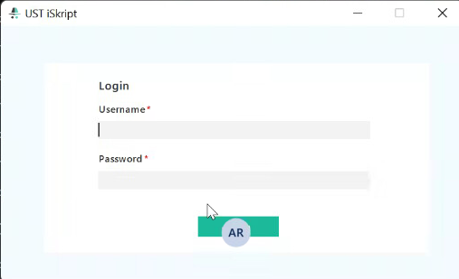

- The projects allocated to the logged in user will show up in the project drop down list. Select the appropriate Project and Application

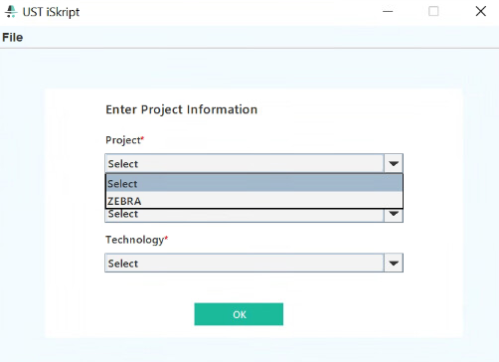

- Select Technology as ‘Native-Apps’
- Connect the Android device to the System and enable USB Debugging Mode in Developer options of your mobile device.
- Check if device is connected
- Open Command Prompt - C:\Users\U123>
- Type command – C:\> adb devices (Shows whether device is online or offline, if offline then reconnect your mobile device).
- Click Capture screen shot icon on top left corner of iSkript Native- Apps screen. (If it takes much time more than a minute, then kill the adb server by using the command C:> adb kill-server and start the adb server again by using the command C:> adb devices)

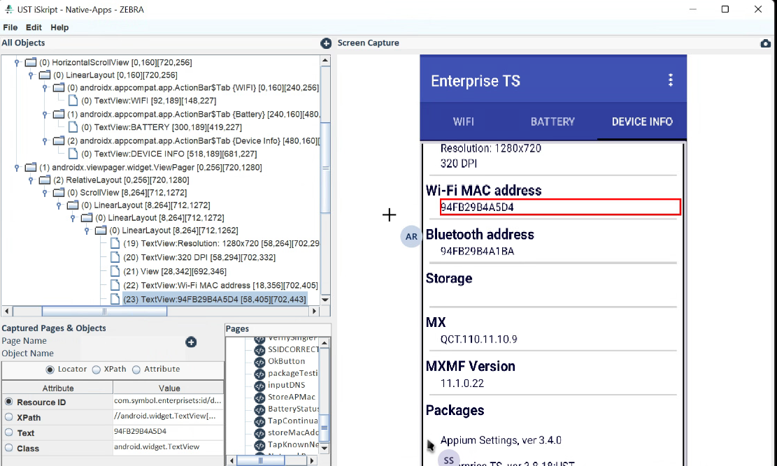

Alternatively, locators can be captured using Appium. Download and Install Appium from https://appium.io/

